
SRM Institute of Science and Technology
College of Engineering and Technology
School of Computing
Department of Networking and Communications
Academic Year: 2023-24 (EVEN)
Test: CLA-T1 Date: 16.02.2024
Course Code & Title: 18CSC305J – Artificial Intelligence Duration: 50 minutes
Year & Sem: III Year / V Sem Max. Marks: 25

Answer Key
Q. No | Question
1 | The goal of artificial intelligence is ___  - Using a computer to play a game  - Developing an Intelligent Machine  - Using Your Own Intuition to Program a Computer  - Implementing your intellect in a machine
2 | ___ enables an AI agent to communicate with its surroundings.  - Sensors  - Perceivers  - Actuators  - Perceivers and sensors
3 | The action of the Simple reflex agent completely depends upon __________  - Perception history  - Current perception  - Learning theory  - Utility functions
4 | Agents behavior can be best described by ____________  - Perception sequence  - Agent function  - Sensors and Actuators  - Environment in which agent is performing
5 | A search algorithm takes _________ as an input and returns ________ as an output.  - Input, output  - Problem, solution  - Solution, problem  - Parameters, sequence of actions
6 | Which term describes the common-sense of the judgmental part of problem-solving?  a. Values-based  b. Critical  c. Analytical  d. Heuristic  Which term describes the common-sense of the judgmental part of problem-solving?  a. Values-based  b. Critical  c. Analytical  d. Heuristic  Which term describes the common-sense of the judgmental part of problem-solving?  - Values-based  - Critical  - Analytical  - Heuristic
7 | Calculate the value of LATE  Assume T =8, A=3, P=5  - 4638  - 1286  - 4386  - 8346
  TAP
  OFF
  FILE
8 | Pick out the wrong statement solving CSP  - Need for decomposition of problem  - Analyze the problem structure  - Understanding the problem structure  - Directly implementing the problem
9 | The term ___________ is used for a depth-first search that chooses values for one variable at a time and returns when a variable has no legal values left to assign.  - Forward search  - Backtrack search  - Hill algorithm  - Reverse-Down-Hill search
10 | Which technique is commonly used to solve constraint satisfaction problems?  - Genetic algorithms  - Deep learning  - Constraint programming  - Quantum computing
16 | Elucidate the characteristics of AI agent.  - Is the problem decomposable?  - Can Solution steps be ignored or undone?  - Is the Universe Predictable?  - Is a good solution absolute or relative?  - Is the solution a state or a path?  - What is the role of knowledge?  - Does the task require interaction with a person?  Explain each with example
17 | Suppose that you are given 3 jugs A, B, C with capacities 8, 5 and 3 liters respectively but are not calibrated (i.e. no measuring mark will be there). Jug A is filled with 8 liters of water. By a series of pouring back and forth among the 3 jugs, divide the 8 liters into 2 equal parts i.e. 4 liters in jug A and 4 liters in jug B. Draw the complete state space tree.  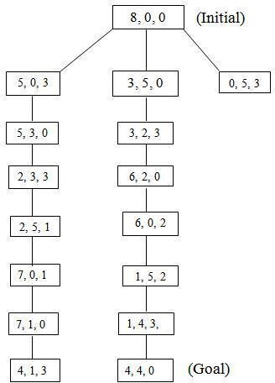
18 | Complete the formulation of below figure as a CSP in terms of variables, domains, and constraints (both unary and binary). Draw the constraint graph.  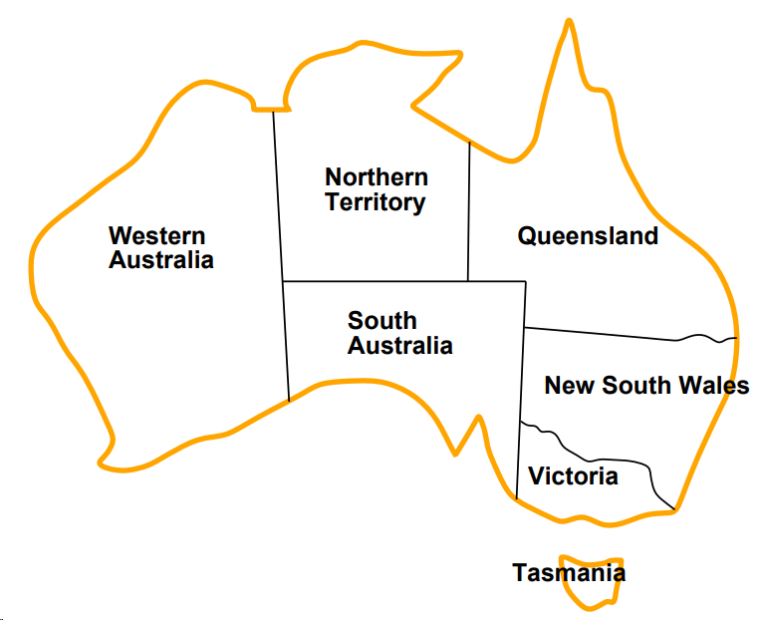  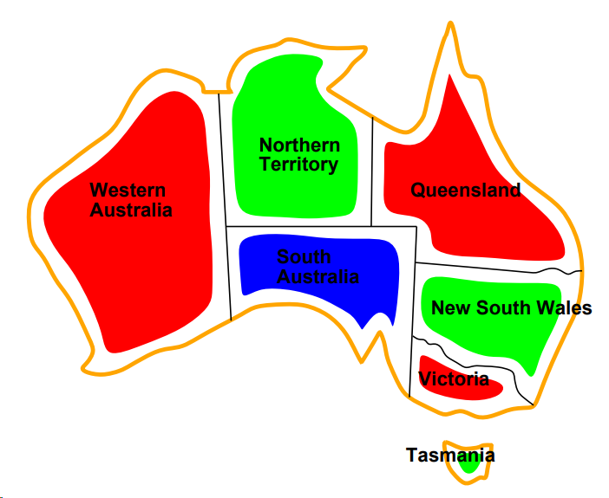  Variables: WA, NT, Q, NSW, V , SA, T  Domains Di = {red, green, blue}  Constraints: adjacent regions must have different colors e.g., WA 6= NT (if the language allows this), or (WA, NT) ∈ {(red, green),(red, blue),(green, red),(green, blue), . . .}  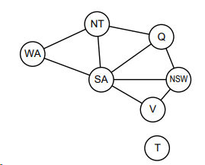
19 | Examine the PEAS descriptor for given environment  - Playing soccer  Performance Measure: scoring goals, defending, speed  Environment: playground, teammates, opponents, ball  Actuators: body, dribbling, tackling, passing the ball, shooting  Sensors: camera, ball sensor, location sensor, other players locator  - Shopping for used AI books on the Internet.  Performance Measure: price, quality, authors, book review  Environment: web, vendors, shippers  Actuators: fill-in the form, follow URL, display to the user  Sensors: HTML

